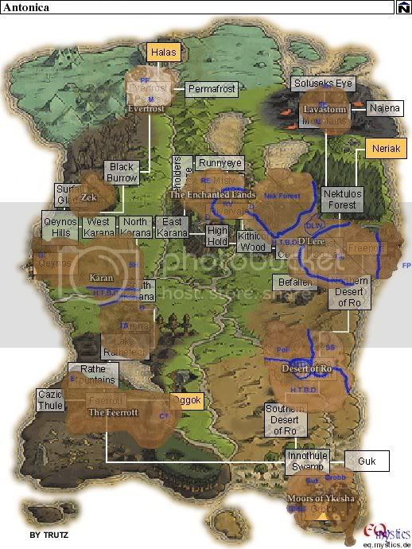

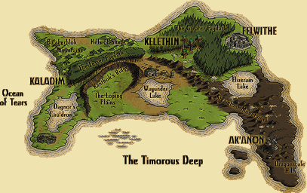

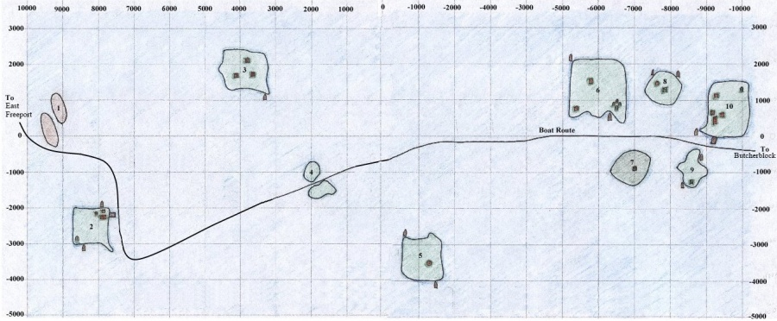

* 1. Several dozen small rocky outcroppings inhabited by Aqua Goblins, Alluring Sirens, and Nerbilik. Brawn also spawns here. There is no boat on these islands.
* 2. Docking point for boats coming from Freeport. Inn sells food and other goods. Stone in southwestern corner of island. Two boats.
* 3. Aviak Island. Three aviak towers and many roaming aviaks, as well as [Gull Skytalon](https://wiki.project1999.com/Gull_Skytalon) who drops [Ingot of the Fervent](https://wiki.project1999.com/Ingot_of_the_Fervent) and [Soarin Brightfeather](https://wiki.project1999.com/Soarin_Brightfeather" \o "Soarin Brightfeather) who drops [Ebon War Spear](https://wiki.project1999.com/Ebon_War_Spear).
* 4. Two rocky spires inhabited by Aqua Goblins and Alluring Sirens. There is no boat here.
* **NOTE: On P99, the east-bound boat will pass just south of the pair of spires at location 4, not through the middle as shown on the map.**
* 5. Island inhabited by Aqua Goblins. Temple on hill in middle of island. The [Allizewsaur](https://wiki.project1999.com/Allizewsaur" \o "Allizewsaur) (spawns at -3060, -660 with an aqua goblin placeholder) roams this island, spending most of its time on the hill near the temple. Two boats.
* 6. Island inhabited by Seafury Cyclops (who are placeholders for Tainted/Corrupt Cyclops), a Buccaneer (who is place holder for Wiltin Windwalker), Gornit, Goob Mudtoe, Quag Maelstrom and a camp of less-than friendly pirates (Toko Binlittle and pet, Dixl Drool, Capt. Surestout). Two boats. Ruined stone ring in southeastern corner.
* 7. Haunted island inhabited by Spectres and Gargoyles who worship at the dark tower. The Sentry spawns here rarely. Gargoyles share spawns with lower-level skeletons, but kill skeletons when their paths intersect. The island will often be full of gargoyles when no one has been killing them, but skeletons spawn respawn quite frequently.
* 8. Island with Boog Mudtoe and Pirate. Also has Temple on north side of hill and old ruined tower on top of hill inhabited by [Elesseryl Terussar](https://wiki.project1999.com/Elesseryl_Terussar" \o "Elesseryl Terussar) who sells Mage spells, mostly summoning spells. Pirate is placeholder for [Ancient Cyclops](https://wiki.project1999.com/Ancient_Cyclops).
* 9. Island of Isle Goblins and [A Goblin Headmaster](https://wiki.project1999.com/A_Goblin_Headmaster) and the [Oracle of K`Arnon](https://wiki.project1999.com/Oracle_of_K%60Arnon) and his Guardian. North point by guardian.
* 10. Island of the Sisters of Erollisi. Dock for boats coming from Antonica. One boat. Stone in northeastern corner. Dwarven smiths on western shore. Inn that sells goods and Kiola Nuts.

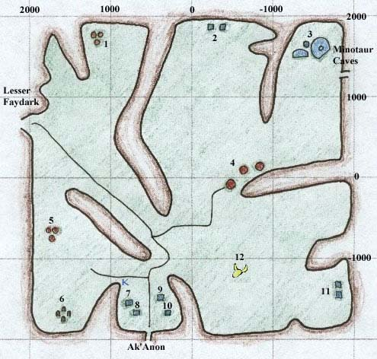

**Steamfont Mountains**

* 1. Kobold Camp
* 2. The Observers
* 3. Haunted Ruins of Giant Clockwork Machine
* 4. The Windmills of Steamfont, several Observers as well as Merchants who sell Ore, Medium-Quality Ore, Dye Materials, Sharpening Stones, Clay, and [Tinkering](https://wiki.project1999.com/Skill_Tinkering) Equipment
* 5. Kobold Camp
* 6. [Druid](https://wiki.project1999.com/Druid) Stone Ring with [Crisyn](https://wiki.project1999.com/Crisyn" \o "Crisyn) selling Spells
* 7. Merchant selling [Sewing](https://wiki.project1999.com/Skill_Tailoring) Supplies, including Large Sewing Kit, How To's, and Needle and Thimble Molds
* 8. Merchant selling Small Armor Molds
* 9. Merchant selling Cookie Molds
* 10. Merchant selling Food and other goods
* 11. Merchants selling Cooking Supplies and Gems for [Jewelry](https://wiki.project1999.com/Skill_Jewelcrafting)
* 12. Dragon Bones with Skeletons

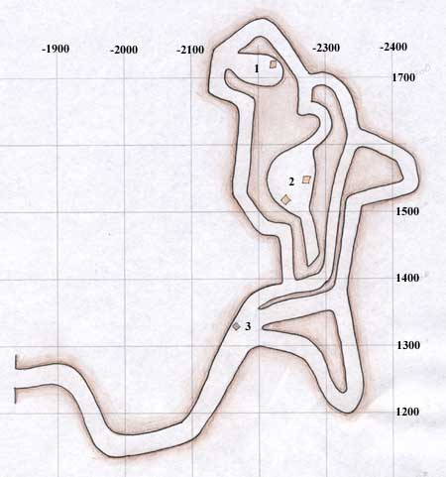

**Steamfont Mountains - Minotaur Caves**

* 1. [Meldrath The Malignant](https://wiki.project1999.com/Meldrath_The_Malignant" \o "Meldrath The Malignant) and Guards
* 2. Slaves
* 3. The Wheelbarrow (pulling spot)

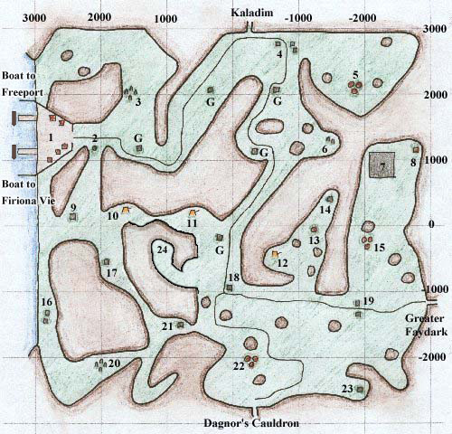

**Butcherblock Mountains**

* G. Guard Houses
* 1. Docks: Northern Pier leads to [Freeport](https://wiki.project1999.com/Freeport), Southern Pier leads to [Firiona Vie](https://wiki.project1999.com/Firiona_Vie" \o "Firiona Vie) in Kunark, Merchants that sell Food and other goods, also many houses representing all the races on Faydwer
* 2. Stone with Guard
* 3. Ancient Stone Ring, protected by Dwarves
* 4. Huts with Merchants who sell Food, Cookie Molds, Smithing Molds, Brewing Supplies and Books, and other Goods
* 5. Goblin Camp
* 6. Partially destroyed Ancient Stone Ring with a small level goblin camp. [A Crazed Goblin](https://wiki.project1999.com/A_Crazed_Goblin) spawns here.
* 7. The Chessboard *("renovated" on 7/14/2013 patch)*
* 8. Dwarf Hut
* 9. Tower with Guards and High Elf Merchant selling Food and other goods
* 10. Bandit Camp with Peg Leg and others
* 11. Goblin Warrior Camp
* 12. Bandit Camp
* 13. Altar
* 14. Stone Pillar protected by Orcs
* 15. Goblin Camp
* 16. Dwarf Houses which sell Leather Armor and Sewing Patterns
* 17. Abandoned Guard House with [Signus Boran](https://wiki.project1999.com/Signus_Boran" \o "Signus Boran) inside
* 18. "The Crossroads" - Guard House with Nyzil Bloodforge
* 19. Merchants who sell Clay, Firing Sheets, Chain Armor, tailoring patterns, [Large Sewing Kit](https://wiki.project1999.com/Large_Sewing_Kit) and other goods
* 20. [Druid](https://wiki.project1999.com/Druid) Ring with Merchant selling [Druid](https://wiki.project1999.com/Druid) Spells
* 21. Haunted Tower
* 22. Goblin Camp, Spawn Point for Corflunk Placeholder
* 23. Stone Tower
* 24. Enraged Goblins

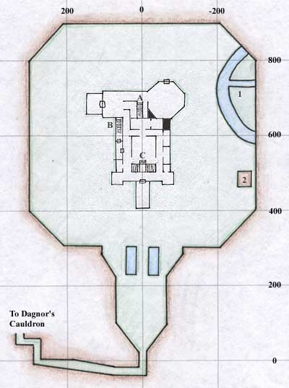

**Estate of Unrest**

* 1. Underground cave with a gnomish spelunker
* 2. The Gazebo
* A. Back Room area with the nearby rare spawn [lesser blade fiend](https://wiki.project1999.com/Lesser_Blade_Fiend) who drops [Gladius](https://wiki.project1999.com/Gladius) (Rare) and [Pugius](https://wiki.project1999.com/Pugius" \o "Pugius) (Rare)
* B. To Basement.
* C. Main Room or MR, and stairs to second floor.

The lettered stairs lead to each other.

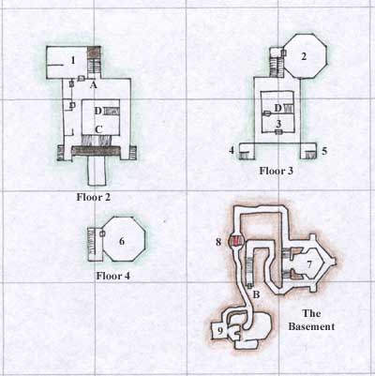

**Unrest Manor**

* 1. Room that spawns [reclusive ghoul magus](https://wiki.project1999.com/Reclusive_ghoul_magus) who drops [Savant's Cap](https://wiki.project1999.com/Savant%27s_Cap) (Common) and [Dusty Bloodstained Gloves](https://wiki.project1999.com/Dusty_Bloodstained_Gloves) (Rare)
* 2. Barroom where spawns: [an undead barkeep](https://wiki.project1999.com/An_undead_barkeep) who drops [Opalline Earring](https://wiki.project1999.com/Opalline_Earring" \o "Opalline Earring) (Common) and [Thick Leather Apron](https://wiki.project1999.com/Thick_Leather_Apron) (Rare), and Zombie of Unrest Noble
* 3. Room with [a reanimated hand](https://wiki.project1999.com/A_reanimated_hand) which drops [Ivory Bracelet](https://wiki.project1999.com/Ivory_Bracelet)
* 4. Tower that spawns [a priest of najena](https://wiki.project1999.com/A_priest_of_najena) who drops Tarnished Bronze Key
* 5. Tower Room
* 6. "Tower" with [an undead knight of Unrest](https://wiki.project1999.com/An_undead_knight_of_Unrest) who drops [Bloodstained Mantle](https://wiki.project1999.com/Bloodstained_Mantle) (Common) and [Bloodstained Tunic](https://wiki.project1999.com/Bloodstained_Tunic) (Rare)
* 7. Main Basement Room, filled with Werebats and Festering Hags
* 8. Blood Trap, be sure to walk *through* the lava, going around it will make you fall in pits
* 9. "Dwarf Room" with [Garanel Rucksif](https://wiki.project1999.com/Garanel_Rucksif" \o "Garanel Rucksif) who drops [Jagged Band](https://wiki.project1999.com/Jagged_Band) (Common) and [Dwarven Work Boots](https://wiki.project1999.com/Dwarven_Work_Boots" \o "Dwarven Work Boots) (Rare), also has Tentacle Terrors who drop [Tentacle Whip](https://wiki.project1999.com/Tentacle_Whip), and Dark Terrors
* A. Fireplace or FP, and stairs to first and second floors.